**Adventures of Gary**

**Team Members**

**Alex Hinz**

**Haris Salihagic**

**Mike Jenks**

|  |  |
| --- | --- |
| **1.0** | **Overview/Story** |
| **1.1** | **Core Gameplay** |
| **1.2** | **UI/HUD** |
| **1.3** | **Music/SFX** |
| **2.0** | **Concept Art** |

1. **Overview/Story**

The player will be playing a character called Gary, Gary used to have a sword that has abilities like fire coming out when swung, Evil Monsters took that sword from Gary, now, Gary has to get it back by finding their secret lair and defeat them to gain back the sword that was taken from him.

**1.1 Core Gameplay**

**Player**

* The player will be given a sword by default to be able to fight enemies.
* The player will have the energy to easily beat the starting enemies they will increase in difficulty throughout your journey.

**Enemies**

* The Enemies will also have a sword by default but one that isn’t as strong as yours or does nearly any damage to you throughout the beginning but over time they will get stronger and maybe specific enemies might have different swords.
* The enemies will have dying animations when they are killed

**Collectables (maybe)**

* Collectables will be either coins or weapon part which you can use to gain another stronger sword that the default one, this sword will be a huge advantage to making sure Gary gets his unique sword back.

**1.2 UI/HUD**

**Player**

* The player will have his/her Health bar top middle of the screen.

**Enemies**

* The enemies will have a health bar above their head to show when they die and how much damage the player is doing.
* The enemy will be able to decrease the player’s health by hitting the player.

**In-Game**

* In-Game UI will be the **pause menu** in which the player can use to **exit** the game, use the **settings** or just use the pause menu for if the player needs to do something in real life really quick.
* Inside of the Settings the player will be able to choose between changing the Audio and changing the Resolution to however they feel.

**Game-Over**

* Inside the **Game-Over** screen you will see a screen to go to **Credits** to see who helped make the game and which team did it.
* When the player sees the **Credits** the player can immediately start the game or just leave to the menu.

**Main-Menu**

* Inside the **Menu** you will find the **Play, Settings, How To Play** and **Exit** each of them the player can go inside and change/ read what they would like
* In **play** you start the game
* In **Settings** you can change resolution and audio
* In **How To Play** there will be a screen showing you how to do basic movement and attacks with default keys
* Lastly **Exit** which exits the game

**1.3 Music/SFX**

**In-Game**

* Very Slow EDM that you can either turn off or keep on, just something to give the player so that the player does not feel bored.

**Game-Over**

* Just a quick looping fast paced and a bit of a higher pitch than normal and catchy

**Main-Menu**

* A quiet catchy song

**Collectables**

* A semi-loud high pitch “ding”

1. **Concept Art**

**In-Game**

**Main-Menu**

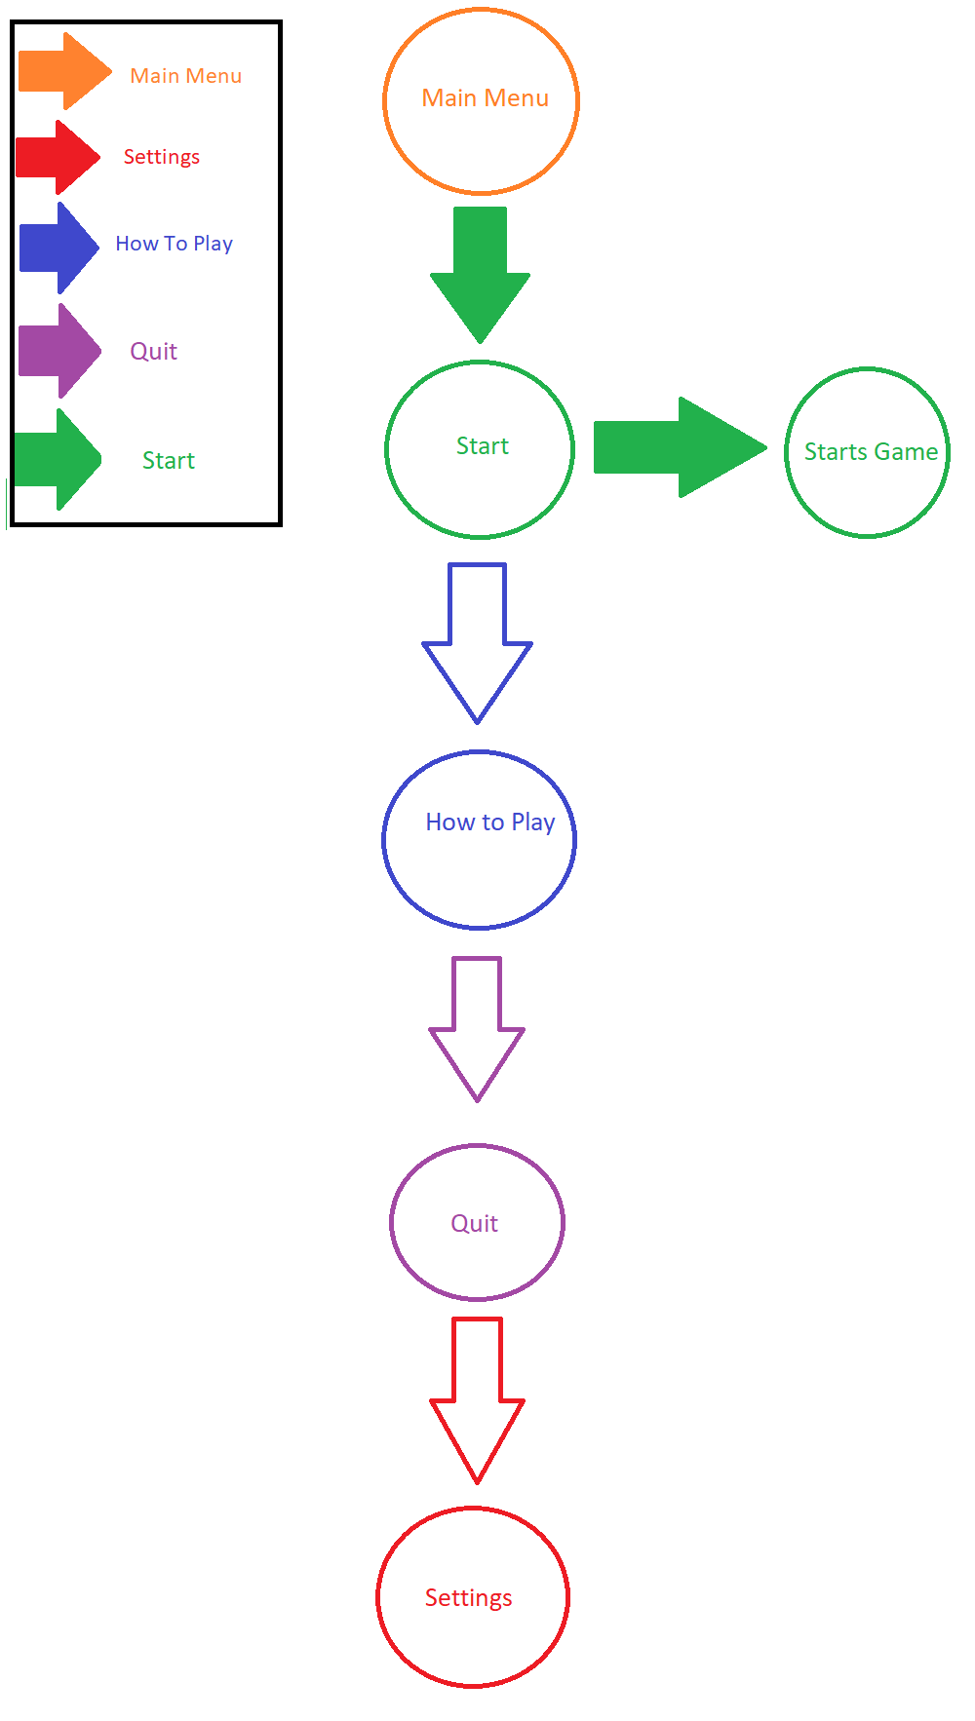

**Game-Over**

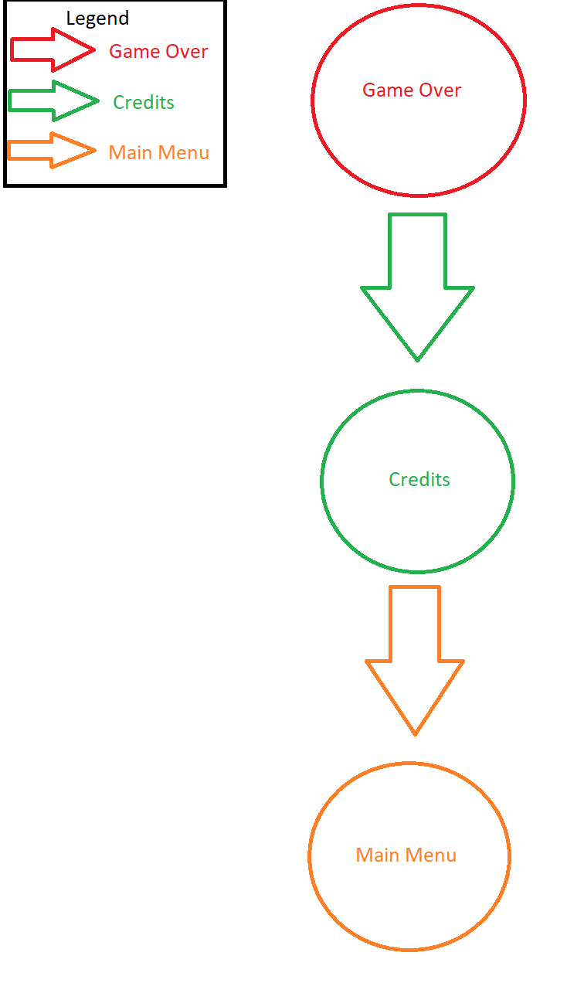

**Pause Menu**

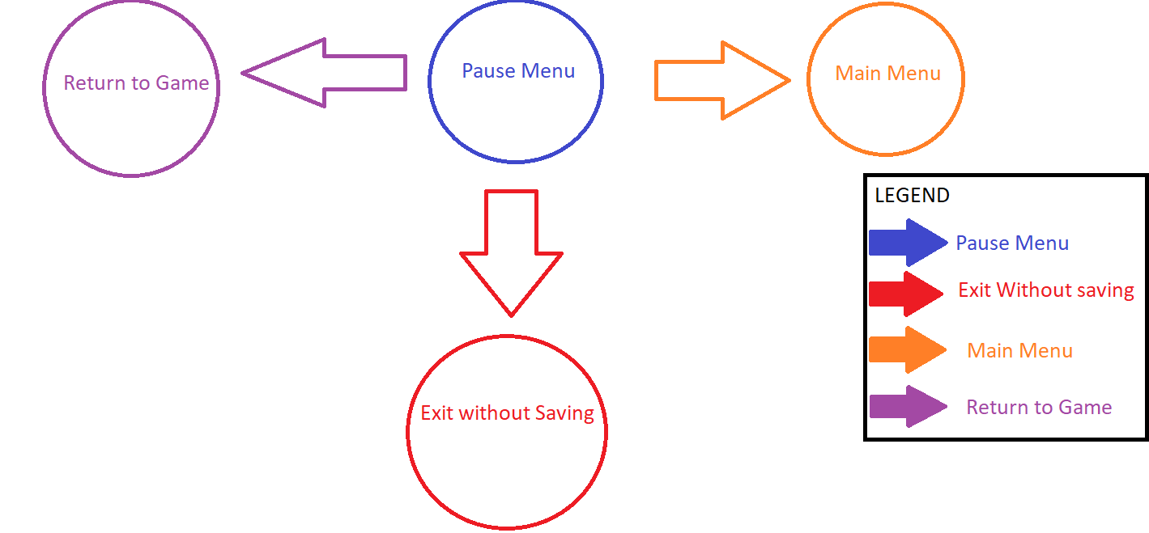

**Collectables(maybe)**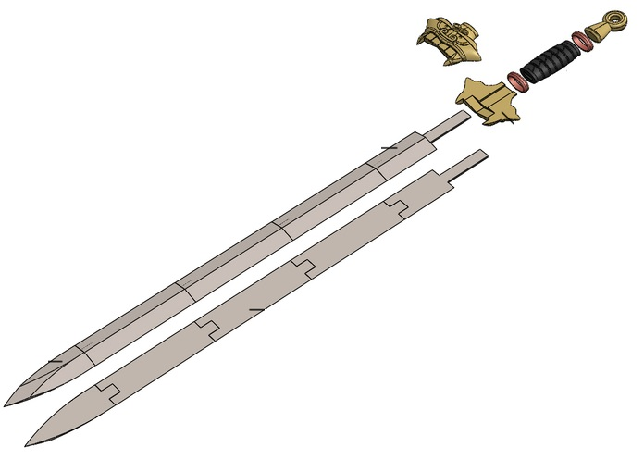

**It is a picture of parts of a sword because the collectables are pieces of a usable weapon later on.**